CHAPTER 1
THE PROBLEM AND ITS BACKGROUND
This chapter presents the overview of the study, including its background, statement of the problem, objectives, scope and limitations, significance, and conceptual framework. It provides the foundation for understanding the issues addressed by the research and the rationale for developing the proposed system.
Introduction
In many academic institutions, the recruitment process remains manual and paper-based, leading to inefficiencies and delays. With the shift toward digital solutions, there’s an opportunity to develop a simple yet functional online recruitment platform tailored to Norzagaray College.
The current manual system often requires applicants to physically submit documents, fill out repetitive forms, and wait extended periods for feedback, resulting in lost opportunities and administrative backlogs. A digital recruitment platform can address these issues by simplifying and organizing the entire process, from job posting and application submission to applicant tracking and communication. It also opens the door for better data management, more consistent evaluation of candidates, and improved accessibility for both applicants and hiring personnel.
Recruitment is a critical component of institutional success because it directly impacts the quality of human capital within an organization. According to Gougous and Paschal (2022), the process of identifying, attracting, interviewing, selecting, hiring, and onboarding employees is a very important personnel policy. In most cases, organizations have relied on conventional recruitment methods such as advertisements and interviews to fill new positions. However, research has shown that these traditional methods have limitations and are often not efficient in selecting the right workforce that will deliver the objectives and goals of the organization. This highlights the importance of adopting a modern recruitment system to improve hiring outcomes at Norzagaray College.
Background of the Study
Recruitment is central to an organization’s ability to succeed, yet many institutions continue to depend on manual, paper-based systems that lead to delays, inefficiencies, and higher costs. Digital recruitment platforms present an opportunity to transform this process.
Arman (2023) conducted a systematic review showing that e-recruitment improves both time and cost efficiency by simplifying applicant management, widening candidate reach, and speeding up hiring cycles. Similarly, Shrivastav, Shrivastav, and Ranjan (2025) found that online tools such as online job portals and social media reduce operational expenses and accelerate recruitment, particularly in fields where access to technical talent is critical.
Beyond operational efficiency, user experience is also an important factor. Wijaya et al. (2022) found that Indonesian millennials, who are highly familiar with digital environments, consider online recruitment platforms more convenient and accessible, making them especially attractive in the post-pandemic labor market.
At the same time, technology must respond to the expectations of both applicants and recruiters. Research by Grimaldo, Uy, and Manalo (2020) in the Philippines showed that while job seekers often find e-recruitment tools useful and easy to use, recruiters sometimes recognize shortcomings in current systems, highlighting the need for more responsive design.
Taken together, these findings indicate that a well-structured digital recruitment platform designed for the context of Norzagaray College can provide measurable benefits in efficiency, cost reduction, candidate reach, and overall user satisfaction, provided it meets the needs of both applicants and administrators.
Setting of the Study
This study entitled NCHire: Developing a Digital Recruitment Platform for Norzagaray College was conducted at Norzagaray College.
Norzagaray College is located in the town of Norzagaray, Bulacan. This place was chosen as the main setting during the Academic year 2025-2026 for where the current recruitment process takes place.
Situated in Norzagaray, Bulacan, Norzagaray College is a recognized higher education institution that offers a range of programs, including Bachelor of Science in Computer Science, Bachelor of Science in Hospitality Management, Bachelor of Education, and an Associate in Computer Technology. The college is dedicated to delivering quality education and is equipped with essential facilities such as a library and computer laboratories. With its strategic location and diverse academic offerings, the institution addresses the educational needs of the community and plays a vital role in the social and economic development of the area.
Norzagaray College was chosen as the research site because of its accessibility and close proximity to the researcher’s residence, which makes the study more practical to conduct.
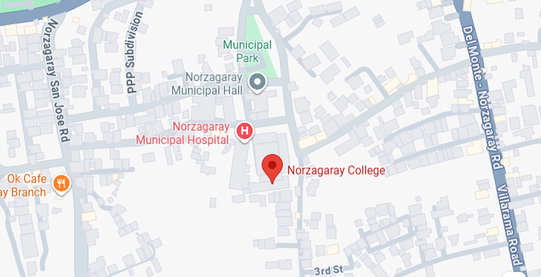

Figure 1. Map of Norzagaray College, Norzagaray, Bulacan
Statement of the Problem
The current recruitment platform at Norzagaray College is manual, which makes the hiring process inefficient and delayed. From that, this study aims to develop NCHire, a digital recruitment platform designed to improve and digitize the college’s job application process for faster, more organized, and accessible recruitment.
General Problem
The research entitled “NCHire: Developing a Digital Recruitment Platform for Norzagaray College” addresses the challenges of traditional, paper-based recruitment. In line with this, the study asks: How can a digital recruitment platform be developed to optimize the job application process for Norzagaray College?

Specific Problem
- How can the platform minimize delays and redundant tasks in the traditional manual handling of job applications?
- How can the system be developed to ensure high usability that leads to a more efficient application experience for its users?
- How can the system handle sensitive data in terms of data security, confidentiality, and integrity?
- How can the system be tested to verify its functionality, reliability, and security?
- How can the system be evaluated in terms of its overall impact on the recruitment process and its alignment with institutional goals, following the International Standard ISO/IEC 25010 for software quality evaluation?
General Objectives
Through the research entitled NCHire: Developing a Digital Recruitment Platform for Norzagaray College, this aims to optimize the institution’s job application process by addressing the limitations of traditional, paper-based recruitment methods. The system seeks to provide a more efficient, organized, and user-friendly approach to managing job postings, applicant records, and recruitment workflows, thereby improving the overall efficiency and accessibility of the college’s hiring operations.
Specific Objectives
This study aims to develop NCHire: Developing a Digital Recruitment Platform for Norzagaray College. Specifically, it seeks to:
- To develop a digital recruitment platform that minimizes delays and repetitive tasks in the manual handling of job applications by improving processes such as application submission, document management, and applicant tracking.
- To develop a system with a user-friendly interface that ensures ease of use and provides a more efficient and satisfactory experience for applicants, faculty, and administrators.
- To develop and implement security mechanisms within the system that ensure the proper handling of sensitive data in terms of data security, confidentiality, and integrity.
- To test the system’s functionality, reliability, and security to ensure it meets expected performance standards.
- To evaluate the system’s overall impact on the recruitment process and its compliance with the ISO/IEC 25010 software quality model, focusing on characteristics such as efficiency, usability, reliability, and security.
Significance of the Study
This study is significant because it aims to enhance the recruitment process of Norzagaray College through the development of the NCHire Digital Recruitment Platform. The findings of this study are expected to benefit various groups within the institution, as outlined below.
Norzagaray College. This study will benefit Norzagaray College as it will lessen the manual process that causes inefficient and delays for the applicants who are looking for the position in Norzagaray College. The institution can fill vacant positions improving overall operational efficiency and supporting its goal of maintaining quality education with a faster and more organized hiring process.
Secretary. The platform will help the college secretaries manage and organize recruitment records more efficiently. This will enable secretaries to provide more accurate and timely support to the deans and the administration during the recruitment process.
Applicants. Applicants can apply online, track their applications status and receive updates right away. This will benefit them in a more convenient and accessible application process and this digital platform will make the experience less time-consuming and more transparent for job seekers.
Dean. The platform will assist the deans in effectively overseeing recruitment activities and applicant information. It minimizes manual and repetitive tasks such as organizing applications and arranging interview schedules, allowing the deans to devote more time to assessing applicant qualifications and making sound hiring decisions.
School Administration. The platform will serve as a dependable information system for the school administration, providing comprehensive access to applicant data and recruitment reports. Through this, the administration can enhance decision-making processes, ensure accountability, and utilize institutional resources more efficiently.
Researchers. This study will serve as a valuable reference for researchers who wish to explore recruitment systems and the digitalization of human resource processes in academic institutions. By examining how the system addresses common issues such as delays, inefficiencies, and lack of transparency in the recruitment process, researchers can gain insights into practical applications of technology in organizational settings. Furthermore, this study can guide researchers in identifying challenges, limitations, and opportunities for innovation in the design and implementation of recruitment systems.
Future Researchers. Future researchers can build upon this study by enhancing the system with more advanced technologies, such as AI-assisted applicant screening or predictive analytics, to further improve the efficiency, accessibility, and accuracy of recruitment processes.
Scope and Limitation of the Study
This study focuses on the development of a digital recruitment platform for Norzagaray College. It aims to design and implement a system that simplifies and organizes the hiring process within the institution. The researchers will gather perspectives from the Dean and faculty members regarding their experiences with the current recruitment process and how it can be improved through the implementation of NCHire.
The system developed for this study includes features commonly found in digital recruitment platforms. On the admin side, the platform allows them to create and manage job postings, schedule interviews, track applicant submissions, and manage applicant records efficiently. Administrators can also add or update accounts, monitor recruitment progress, and send notifications or announcements to applicants. On the user side, applicants can create an account, browse available job postings, submit applications and requirements, receive real-time updates regarding their application status, and manage their submitted documents. Applicants are also able to resubmit updated files when necessary and receive interview schedules directly through the platform. These features aim to provide convenience for applicants while reducing repetitive tasks for the dean.
This study primarily involves individuals who are directly engaged in the recruitment process at Norzagaray College, including potential job applicants, faculty members, and especially the dean. The research will examine how the digital platform can enhance efficiency, accessibility, and transparency compared to the traditional hiring method and determine the benefits of its use.
However, the entire hiring system of other institutions or recruitment practices outside Norzagaray College is not covered in this study. The research will be conducted during the first semester of the academic year 2025–2026, focusing only on the development and evaluation of the proposed digital recruitment platform.
Despite its wide range of features, the system also has certain limitations. The platform is exclusively developed for Norzagaray College and cannot be utilized for recruitment processes outside the institution. While it facilitates the submission and organization of applications, the system does not include automated evaluation tools such as applicant ranking or skill-matching algorithms; hence, the final screening and hiring decisions remain under the responsibility of the dean.
Moreover, document verification for authenticity is not automated and will still be manually conducted. The system also requires applicants to have access to a stable internet connection and basic knowledge of digital platforms in order to navigate the application process. Furthermore, advanced recruitment functions such as salary negotiations, onboarding processes, or payroll management are not covered by the system, as its focus is solely on digital recruitment. Real-time communication tools such as live chat or video conferencing are also not integrated into the platform, limiting applicant-recruiter interaction to system notifications.
Finally, while the system is designed for both desktop and mobile browsers, a dedicated mobile application is not yet included in its current scope.
Definition of Terms
Accessibility – Refers to how easily applicants and the dean can use the digital recruitment platform anytime and anywhere, as long as they have internet access.
Algorithm – The step-by-step instructions or processes built into the system to make tasks like searching, sorting, or verifying applicant data faster and more organized.
Applicant Data – The personal, educational, and work-related information submitted by applicants through the platform, which is stored in the system’s database for recruitment purposes.
Applicants – Individuals who submit their application forms and requirements online to be considered for a position at Norzagaray College.
Applicant Tracking System – A feature of the platform that helps the dean organize, review, and follow the progress of applications from submission to final decision.
Automated – Describes the platform’s ability to perform recruitment tasks such as sending updates with minimal human involvement.
Benefits – The improvements gained from using the recruitment platform, such as faster processing, less paperwork, and more transparent communication.
Database – The organized collection of applicant records stored electronically within the system for secure access and easy retrieval.
Data Privacy – The protection of applicant information so that it is only used for recruitment and cannot be accessed or misused by unauthorized persons.
Dean – The person responsible for reviewing and making final decisions on applications submitted through the platform.
Efficiency – The ability of the platform to reduce delays and complete recruitment tasks with less effort, cost, and time.
Manual System – The old, paper-based process of recruitment where applications were submitted physically and sorted by hand.
Online Job Applications – Application forms and documents submitted digitally through the platform instead of through physical paperwork.
Recruitment Platform – The digital system developed in this study (NCHire) that handles job postings, applicant submissions, and recruitment records.
School Administration – The body of officials at Norzagaray College that oversees recruitment policies and benefits from organized applicant data.
Software – The set of programs and tools used to build and operate the recruitment platform.
Storage – The way applicant information and documents are safely kept in the platform’s database for future reference.
Transparency – The openness of the recruitment process, allowing applicants to track their application status and receive clear updates.
User Experience (UX) – The overall convenience and satisfaction that both applicants and the dean feel when using the platform.
Theoretical Framework
This study is grounded on the Technology Acceptance Model (TAM) developed by Davis (1989), which explains how users come to accept and use technology. TAM suggests that users’ decisions to adopt a system are influenced primarily by their perceptions of the system’s usefulness and ease of use.
In the context of NCHire, a digital recruitment platform for Norzagaray College, perceived usefulness refers to how applicants, deans, and administrators believe that the system can enhance the efficiency and effectiveness of the recruitment process, such as reducing delays and eliminating redundant manual tasks. Perceived ease of use reflects the degree to which users find the platform simple and convenient to navigate, allowing them to submit applications, upload requirements, and manage job postings without unnecessary effort.
According to TAM, these perceptions influence users’ attitudes toward using the system, which then shapes their intention to use it and ultimately affects actual usage. Therefore, the more users view the platform as both valuable and user-friendly, the more likely they are to adopt it. Applying this model to NCHire provides a framework for understanding factors that encourage or hinder acceptance of digital recruitment within Norzagaray College, offering insights to improve the platform’s design, functionality, and overall adoption.

Conceptual Framework

Knowledge Requirements
Understanding of online recruitment processes and best practices
Familiarity with dean workflows and applicant tracking systems
Programming knowledge in HTML, CSS, PHP, JavaScript, React, and MySQL (for database management)
Basic knowledge of data privacy and security for online applications
Awareness of user experience (UX) principles for web platforms
Algorithms
Binary Search, QuickSort, Knuth-Morris-Pratt (KMP) Algorithm, Session Management Algorithm, CRUD Operation Algorithms, Secure Hash Algorithm (SHA-256)
Hardware Requirements
Laptop ( Intel i5 processor )
RAM 8 GB
Storage (256 GB SSD )
Software Requirements
Visual Studio Code
Windows 10
Tailwind
XAMPP
MySQL

Requirements
Design
Development
Testing
Deployment
Review

NCHire: Developing a digital recruitment platform for Norzagaray College

INPUT

PROCESS

OUTPUT

Evaluation

Figure 2. IPO (Input-Process-Output)
This study focuses on developing a digital recruitment platform for Norzagaray College, requiring a combination of technical knowledge, tools, and resources as inputs. Knowledge inputs include understanding online recruitment processes, dean workflows, applicant tracking systems, UX principles, and data security, while technical skills involve programming languages such as HTML, CSS, PHP, JavaScript, React, and MySQL, alongside algorithms like Binary Search, QuickSort, KMP, session management, CRUD operations, and SHA-256. Hardware and software inputs include a laptop, Windows 10, Visual Studio Code, Tailwind, XAMPP, and MySQL. The development follows an Agile methodology, progressing iteratively through requirements gathering, system design, coding and integration, continuous testing, deployment, and review, allowing for ongoing refinement based on user feedback. The output is a fully functional, efficient, and user-friendly digital recruitment platform that improves the management of applications, enhances administrative efficiency, and provides a better experience for both users of the platform.

CHAPTER 2
REVIEW OF RELATED LITERATURES
This chapter presents a comprehensive review of existing literature and studies relevant to the topic under investigation. By examining previous research, theoretical frameworks, and documented findings, this chapter aims to provide a solid foundation for understanding the context, trends, and gaps that inform the current study. The synthesis of related literature highlights key concepts, methodologies, and outcomes from prior works, which serve as a basis for the formulation of research questions, objectives, and the overall significance of the study.
Job Posting Management
Job Posting Management refers to the processes and software components that enable organizations to create, structure, categorize, publish, and maintain job vacancy information on a centralized platform. Good job-posting systems support taxonomy/category schemas, templated descriptions, metadata for filtering (skills, experience, location), and interfaces for real-time updates so that job seekers can discover relevant vacancies with minimal friction.
Content-based and hybrid job recommender prototypes have been widely explored in the last few years as an academic approach to improving vacancy discovery and matchmaking. A practical example is the content-based job recommender described by Hawari et al. (2022), who implement a content-based filtering pipeline for a job portal and report how text similarity and feature extraction improve the relevance of vacancy lists for users; the authors make their system and evaluation available. Another notable system is BISTRO (Han et al., 2024), a session-based behavioral-semantic fusion framework developed for job recommendation that explicitly models user preference drift and fuses semantic clustering with behavioral signals to deliver timely, personalized job suggestions; BISTRO was published as KDD 2024 work and demonstrates strong online/offline performance on recruitment datasets. Finally, other predictive job recommendation systems combine collaborative and content techniques to present ranked vacancy lists that adapt as users interact with the portal. Together, these systems show that job posting management in modern CS systems benefits from structured metadata, semantic representations of postings, and real-time user interaction logging to improve vacancy discovery.
Job Posting Management in our system will allow recruiters to create job descriptions, categorize postings based on industry or role, and publish them in real time. It will also support job status monitoring (e.g., active, paused, closed), enabling efficient management of open positions.
Applicant Tracking System (ATS)
An Applicant Tracking System (ATS) is software that automates the process of receiving, screening, and managing job applications. It organizes applicant data and helps recruiters track each candidate’s progress through the recruitment pipeline.
Several recent CS prototypes and published systems illustrate modern ATS advances. Resume2Vec (Bevara et al., 2025) proposes transformer-based resume and job-description embeddings to move beyond keyword matching; the study describes architecture, compares transformer encoders for resume representation, and reports improvements in matching accuracy over lexical baselines. Another prototype, Intelligent Resume Parsing and Job Recommendation via Web-Based CV Analysis (Sanyal et al., 2025), demonstrates a lightweight web system that extracts structured fields from PDF resumes and then queries job APIs to return candidate-job matches, the paper includes implementation details and discusses practical issues like PDF format variance and OCR limitations. In addition, several research efforts describe ATS pipelines that combine NLP (for section detection and entity extraction) and traditional ML classifiers (including KNN/ensemble methods) to classify and rank applicants; for example, an "Advanced Applicant Tracking System" prototype (Chavan et al., 2023) shows how NLP + KNN components can automate screening and reduce manual workload. Collectively these works show the feasibility and benefits of embedding-driven matching, robust resume parsing, and modular ATS design.
The ATS module in our system will parse resumes into structured data, allow keyword-based filtering of candidates, and maintain applicant status dashboards (e.g., Applied, Shortlisted, Interviewed). This integration ensures transparency, data-driven hiring decisions, and streamlined candidate management.
Interview Scheduling
Interview Scheduling is the sub-system that coordinates calendar availability between candidates and interviewers, proposes slots, sends reminders, and minimizes conflicts across panels and time zones. It refers to the automated coordination of interview appointments between recruiters and applicants, minimizing conflicts and communication delays.
Several academic prototypes focus on automation and algorithmic scheduling. Automated Application Processing (Sharma et al., 2022) explicitly models interview scheduling and reviewer/panel assignment as algorithmic sub-problems; the authors present prototype algorithms, evaluate them on real datasets, and show improved throughput and better utilization of reviewer expertise compared to manual planning (arXiv PDF). In parallel, domain studies and industry analyses demonstrate that calendar synchronization, self-scheduling, and automated reminders substantially reduce coordination delays and no-show rates; recent HR research and industry reports summarize these operational gains and outline implementation patterns (HR.com / Yello / industry whitepapers). Together, the academic scheduling algorithms and industry practice indicate that automated scheduling can be implemented reliably and that it yields measurable improvements in process time and candidate experience.
The system will assist in interview scheduling by allowing recruiters to set their available time slots and letting applicants choose from these options. Once a slot is selected, both parties will receive automated reminders. The system will also provide a simple option for rescheduling to maintain smooth coordination.
Notification System
A Notification System provides automated alerts and updates to users about application progress, interview schedules, and other recruitment-related activities. Peicheva (2022) highlighted that timely notifications improve communication transparency in recruitment, helping applicants remain informed about their status. He et al. (2025) further argued that fair and transparent notifications are essential in ensuring that candidates feel respected and engaged throughout the hiring process.
Research on explainability and candidate trust highlights the role of transparent communication in recruitment tech. Let's Get You Hired: A Job Seeker’s Perspective on Multi-Agent Recruitment Systems for Explaining Hiring Decisions (Bhattacharya & Verbert, 2025) presents a multi-agent prototype where explainable text and status updates improve candidate perceptions of fairness and usability; the system design explicitly uses agent messages and notifications as part of the feedback loop. More applied work (e.g., automated application processing prototypes and system descriptions) documents that explicit notification channels reduce candidate uncertainty and dropout (Sharma et al., 2022; other implementations). Together, these studies show that notification systems are not only technical plumbing but also have an observable UX and fairness effect.
The Notification System in our project will send automated alerts via email messages regarding status changes, interview reminders, or missing documents. This ensures that both recruiters and applicants are kept informed in real time.
Real-Time Application Updates
Real-Time Application Updates enable applicants to instantly view changes in their application status, such as submission confirmation, review progress, or interview scheduling. He et al. (2025) proposed a fair recruitment framework that stressed the importance of immediate feedback to job seekers, as it reduces uncertainty and improves candidate trust. Peicheva (2022) also showed that real-time status tracking in ATS platforms enhances transparency and strengthens applicant engagement. Sharma et al. (2022) highlighted that providing applicants with continuous updates improves their overall recruitment experience and reduces dropout rates.
Modern ATS research emphasizes real-time or near-real-time feedback loops. The MLAR concept (multilayer LLM-based ATS) and embedding-driven systems such as Resume2Vec (Bevara et al., 2025) describe pipelines that can supply immediate processed outputs (parsed resume fields, ranking scores) which are suitable for real-time display. BISTRO (Han et al., 2024) also demonstrates that session-aware recommender outputs can be updated online as users act, suggesting practical architectures for real-time adaptivity in recruitment systems. Research prototypes that combine rapid parsing and streaming updates show improved candidate engagement and lower abandonment.
Our system will provide applicants with a dynamic dashboard showing their application’s status in real time. Recruiters can update statuses with one click, and applicants will immediately be notified. This fosters transparency and trust between the institution and the applicants.

Benchmarking
To further understand the context of the study, benchmarking was conducted on existing recruitment and job management systems developed in recent years. Benchmarking allows a comparison of the features, contributions, and focus of related systems with the objectives and modules of the present study. This process helps identify which aspects have already been addressed in previous research and which gaps remain to be filled.
Features | Job Recommendation System Using Content-Based Filtering Method | Resume2Vec: Resume Understanding via Transformer-Based | Advanced Applicant Tracking System with NLP and KNN | Explainable Multi-Agent Recruitment System | Multilayer LLM-Based ATS (MLAR) | NCHire: Developing a Digital Recruitment Platform for Norzagaray College
Job Posting Management | ✓ |  |  |  |  | ✓
Applicant Tracking System (ATS) |  | ✓ | ✓ |  |  | ✓
Interview Scheduling |  |  | ✓ |  |  | ✓
Notification System |  |  |  | ✓ |  | ✓
Real-Time Application Updates |  |  |  |  | ✓ | ✓
Table 1. Benchmarking

Synthesis
The benchmarking of related systems reveals that while recent studies have contributed to improving recruitment processes, there is still a clear need for an integrated platform that addresses multiple stages of the hiring cycle. The Job Recommendation System Using Content-Based Filtering (Hawari et al., 2022) and the Learning-Based Matched Representation System for Job Recommendation (Liu et al., 2022) demonstrate how structured posting and content-based matching can make vacancy distribution more efficient and accurate. These findings are relevant to our study’s objective of developing a Job Posting Management module that organizes postings by category and industry while ensuring that applicants are better matched to opportunities.
In addition, resume parsing and candidate evaluation systems such as Intelligent Resume Parsing and Job Recommendation (Sanyal et al., 2025) and Resume2Vec (Zhu et al., 2024) show that automated processing reduces manual recruiter effort and provides more reliable candidate-job alignment. These works strengthen the need for an Applicant Tracking System (ATS) in our study, which will convert resumes into structured data and allow recruiters to filter applicants according to qualifications. This supports our objective of creating a process that is both accurate and transparent for decision-making.
The importance of interview coordination is emphasized in Chavan et al.’s (2023) ATS with NLP and KNN, which incorporates automated scheduling functions. This supports the inclusion of an Interview Scheduling module in our system, as it will address scheduling conflicts and communication delays by providing suggested time slots and reminders. This directly relates to our objective of reducing inefficiencies during the interview stage.
Notification systems have also been highlighted as essential for communication. The Explainable Multi-Agent Recruitment System (Bhattacharya & Verbert, 2025) demonstrates how consistent and transparent notifications contribute to fairness and candidate engagement. This aligns with our objective of implementing a Notification System that informs applicants and recruiters of status changes, deadlines, and interview reminders through multiple communication channels.
Finally, the need for immediate status tracking is addressed in studies such as BISTRO (Han et al., 2024) and the Multilayer LLM-Based ATS (Younes et al., 2025), which show that real-time updates strengthen applicant trust and reduce uncertainty. These insights support the development of our Real-Time Application Updates module, which will allow applicants to see the progress of their applications as soon as recruiters make updates.
Overall, the review of related systems demonstrates that while individual aspects of recruitment have been addressed in prior research, these systems are often limited to specific functions such as job posting, resume parsing, or notifications. Our study addresses this gap by integrating these features into a single recruitment management system. In doing so, it responds to the need for a platform that is organized, transparent, and accessible for both recruiters and applicants.

CHAPTER 3
DESIGN AND METHODOLOGY
This chapter outlines the methods and procedures used in conducting the study. It describes how the research was designed, developed, and evaluated to ensure that the results are accurate and reliable.
Organizational Chart
The organizational chart for the NCHire Digital Recruitment Platform shows the structure of the development team and their respective roles in the project. It clarifies the hierarchy and responsibilities among members involved in system development. This structure ensures coordination, accountability, and efficient communication throughout the project.
JOHN KENNEDY B. LORENZANA Project Manager, Documenter

MONICA S. OROLFO Tester, Documenter
KYLA MAE J. MEDICO Documenter, UI Designer

JOHN PAUL MANANSALA Lead Developer

Figure 3. Organizational Chart

Figure 3 illustrates the project’s organizational chart. John Kennedy B. Lorenzana, as the Project Manager and Documenter, stands at the top of the hierarchy. He oversees the entire development process, coordinates schedules, and ensures that all project documentation is accurate and complete. Working with him are Monica S. Orolfo, who serves as Tester and also one of the Documenters and is responsible for testing the system and doing the paper; Kyla Mae J. Medico, the UI Designer, who focuses on creating a user-friendly interface for both the Dean and the applicants and also documenter; and John Paul Manansala, the Lead Developer, who manages database integration, coding, and overall platform functionality. Together, they collaborate to ensure the successful development of NCHire: Developing a Digital Recruitment Platform for Norzagaray College.
Project Member’s Roles and Responsibilities
To ensure the smooth development of NCHire: Developing a Digital Recruitment Platform for Norzagaray College, each member of the team has specific duties and responsibilities. Their combined efforts support the project’s objectives and timeline.
Table 2. Roles and Responsibilities of the Project Team Members

Member’s Role | Duties and Responsibilities
Project Manager & Documenter  Lorenzana, John Kennedy B. | He serves as the overall leader of the project and is responsible for managing its progress from start to finish. He plans and organizes schedules, ensuring that tasks are completed on time. He organized meetings and assigns work to each team member. He also makes sure that all documentation is properly written, accurate, and complete.
Tester & Documenter  Orolfo, Monica S. | She is in charge of testing the platform to confirm that it works according to the requirements. She checks the system’s functionality. She shares the results of testing to the programmer for improvements. She also helps prepare project documentation, supporting the Project Manager in keeping reports clear and organized.
UI Designer & Documenter  Medico, Kyla Mae J. | She focuses on providing suggestions to improve the user interface design, ensuring that it remains clear, accessible, and easy to navigate. She collaborates with the developer by giving feedback on the visual aspects to maintain consistency between the design and system functionality. She also serves as one of the documenters of the project.
Lead Developer  Manansala, John Paul | He is responsible for creating both the back-end and front-end of the platform. He connects the database with the user interface to make sure data flows smoothly. He develops the core features that allow applicants and the Dean to interact with the system effectively.

Table 2 highlights the specific duties of each member of the NCHire project team. It shows how responsibilities and duties are divided so that every aspect of the platform’s development is covered. The table also emphasizes teamwork, where planning, designing, coding, testing, and documentation work together toward one goal.
Project Design
This study followed the developmental project design to build the NCHire, a digital recruitment platform for Norzagaray College. This design focuses on creating a system that will help improve and automate the college’s manual recruitment process, making it more efficient, organized and accessible for both applicants and administrators. The development process involved planning, designing, coding, testing and refining the system to ensure it meets the needs for its users. NCHire aims to simplify job posting, application submission and applicant tracking through an easy-to-use web-based recruitment platform.

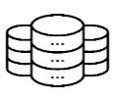
1. System Architecture
Database
Server






Dean
Applicants

NCHire

Admin



Secretary

Figure 4. System Architecture
The system is designed to provide smooth interaction between the administrators, deans, the secretary and applicants of Norzagaray College through the NCHire. It functions as an online platform that organizes and supports the recruitment process by integrating key features such as job postings, application submission, applicant management, and demo scheduling. The administrator holds the highest level of access and is responsible for creating and managing accounts for Deans and other key personnel, such as the Secretary, to ensure proper control and system security. Administrators manage user accounts, while Deans can create job postings, review applications, access applicant information, schedule demos, and update applicant statuses. The Secretary facilitates the transfer of applications to the Deans, and applicants can register, submit forms, upload required documents, and monitor the status of their applications.
All-important data, including user accounts, job postings, applications, and schedules, are stored in a secure and centralized database. When an applicant submits information, it is saved and made available for administrators to review, and any updates made by the administrators are automatically reflected in the applicant’s account. This setup helps reduce errors, minimize delays, and make the recruitment process faster and more reliable. By bringing all recruitment activities into one platform, NCHire provides an effective and accessible way to improve communication and efficiency in the college’s hiring process.

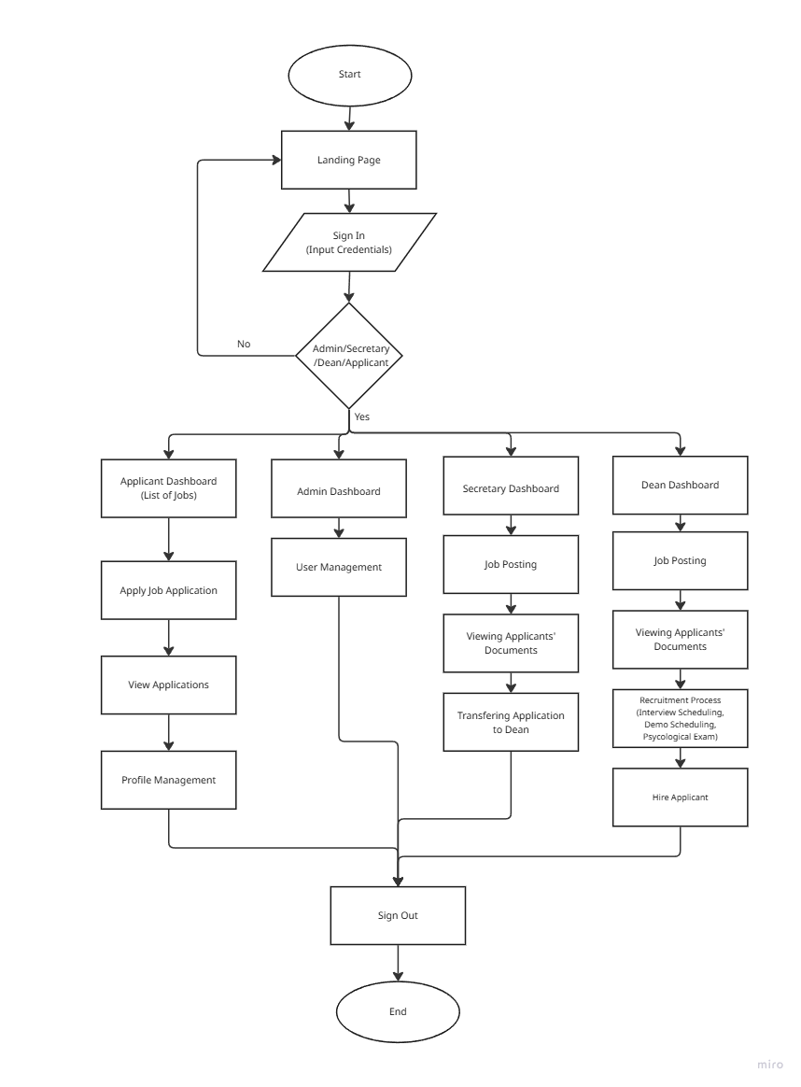
2. Context Diagram

Figure 5. Website Diagram
The context diagram illustrates the overall interaction and flow of processes within the NCHire: Digital Recruitment Platform for Norzagaray College. It provides a high-level overview of how the different users namely the Administrator, Secretary, Dean, and Applicant interact with the system and perform their respective functions.
The process begins at the landing page, where users are directed to the sign-in interface. Upon entering valid credentials, the system verifies their role and redirects them to their designated dashboard. Applicants can access the Applicant Dashboard, where they can view job listings, apply for job vacancies, monitor the status of their applications, and manage their personal profiles.
Administrators oversee the entire system through the Admin Dashboard, which allows them to manage user accounts and ensure proper system operation. Secretaries use the Secretary Dashboard to post available job openings, review applicants submitted documents, and transfer qualified applications to the Dean for further evaluation.
The Dean Dashboard enables deans to view transferred applications, post job openings for their department, and facilitate the recruitment process, which includes interview scheduling, demonstration scheduling, and psychological examinations. Once qualified applicants complete these stages, the dean finalizes the process by confirming the hiring decision. After completing their respective tasks, users may sign out of the system, marking the end of their session. Overall, the context diagram highlights the system’s structured and collaborative design, emphasizing the coordinated roles of different users in automating and organizing the recruitment workflow within Norzagaray College.
3. User Interface (UI) Design - The user interface of NCHire is designed to provide a simple, intuitive, and user-friendly experience for both administrators and applicants. It focuses on accessibility and efficiency, allowing users to easily navigate through the system’s main functions such as job posting, application submission, and applicant tracking. The interface ensures that all elements are clearly organized and responsive, providing a consistent layout across different devices to support a smooth recruitment process for Norzagaray College.
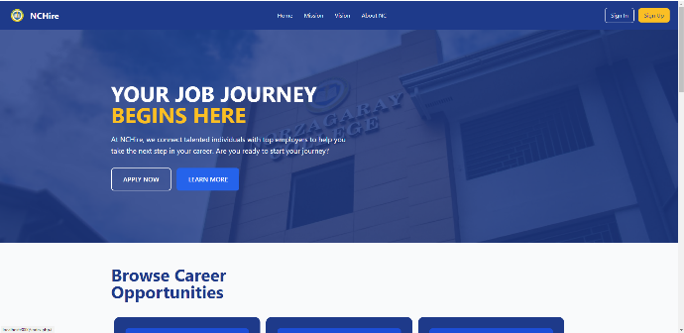
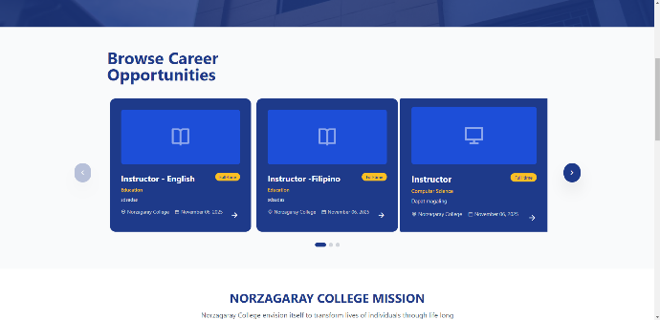
3.1 Desktop Web Application Layout
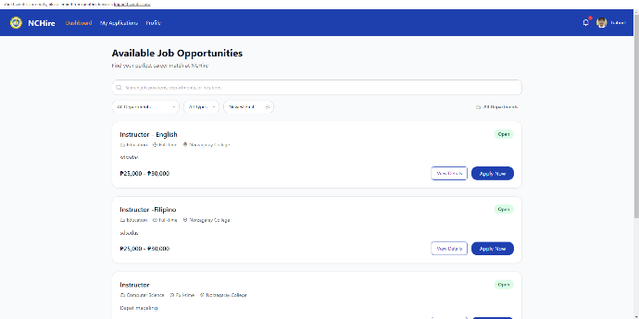
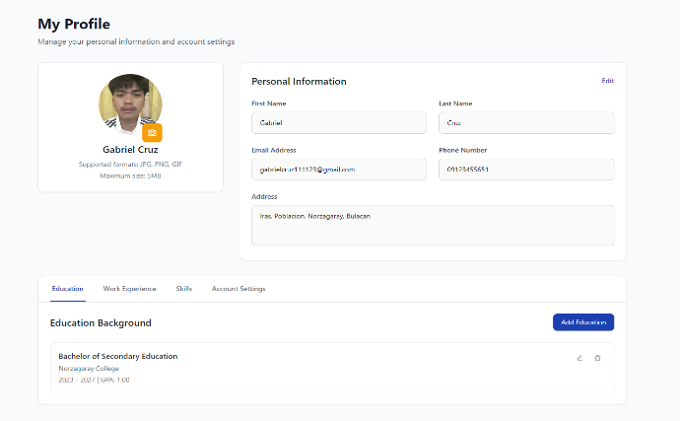
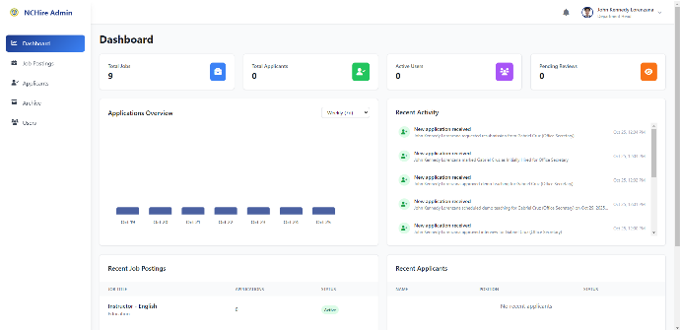
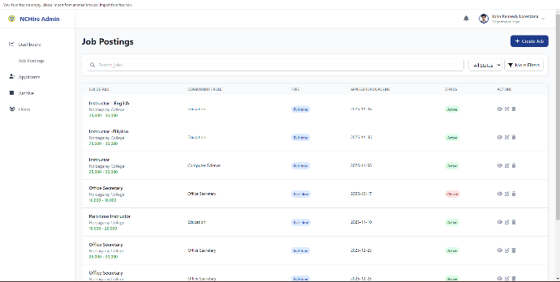


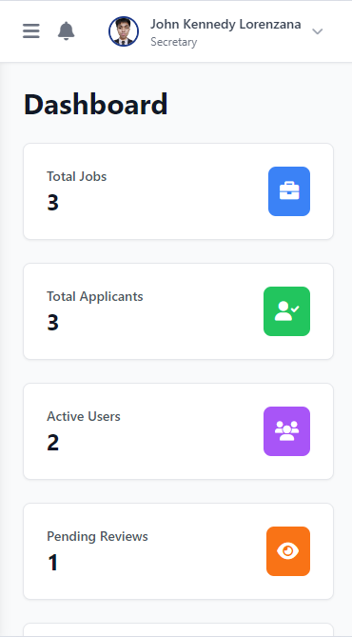
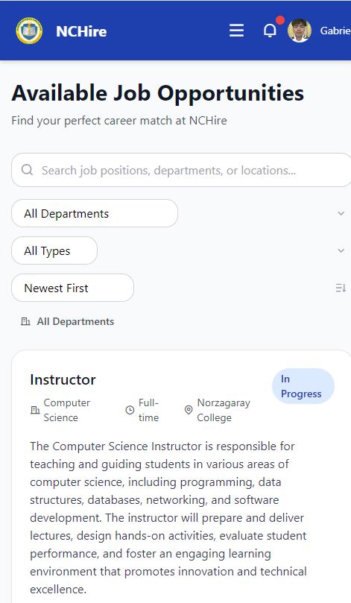
3.2 Mobile Web Layout

4. Technical Specification
The system was developed to make the recruitment process of Norzagaray College more organized and efficient for administrators and applicants. It allows administrators to manage user accounts. Deans can post job openings, manage applications, and review applicant records, while secretaries facilitate the transfer of applications to the appropriate deans and assist in coordinating recruitment tasks. Applicants can register, submit forms, upload documents, and track their application status. The Admin is responsible for creating and managing administrator accounts to ensure proper access control and system management. All information is stored in a secure database, keeping data updated, accurate, and accessible to authorized users. This setup helps improve communication, reduce manual work, and make the overall recruitment process faster and more reliable.
Software Development Methodology
The development of this system follows a flexible approach to ensure efficiency and quality. In this study, we adopt the Agile methodology, specifically the Scrum framework, which emphasizes iterative development, stakeholder collaboration, and continuous improvement throughout the project lifecycle.
The Scrum process guides the development of the recruitment platform through short, manageable iterations known as sprints, allowing the team to continuously refine the system based on user feedback. The process begins with requirements gathering, where user needs and functional specifications are collected directly from stakeholders through interviews. During the design phase, these requirements are translated into interface layouts and database structures. The development phase focuses on implementing core modules such as applicant management and recruitment workflow.
Scrum encourages iterative testing and review, including unit, integration, and user acceptance testing, to identify and resolve issues early while improving usability and documentation accuracy. After each sprint, the team conducts sprint reviews and retrospectives to assess progress and gather feedback for further refinement. The deployment phase introduces the system in a controlled environment demonstration and testing purposes. This allows recruitment personnel and selected users to explore the platform’s features and provide feedback, which will be used to refine and enhance the system for future implementation.
By employing Scrum’s incremental and collaborative approach, the recruitment platform remains aligned with stakeholder requirements, ensuring adaptability, efficiency, and continuous improvement throughout development
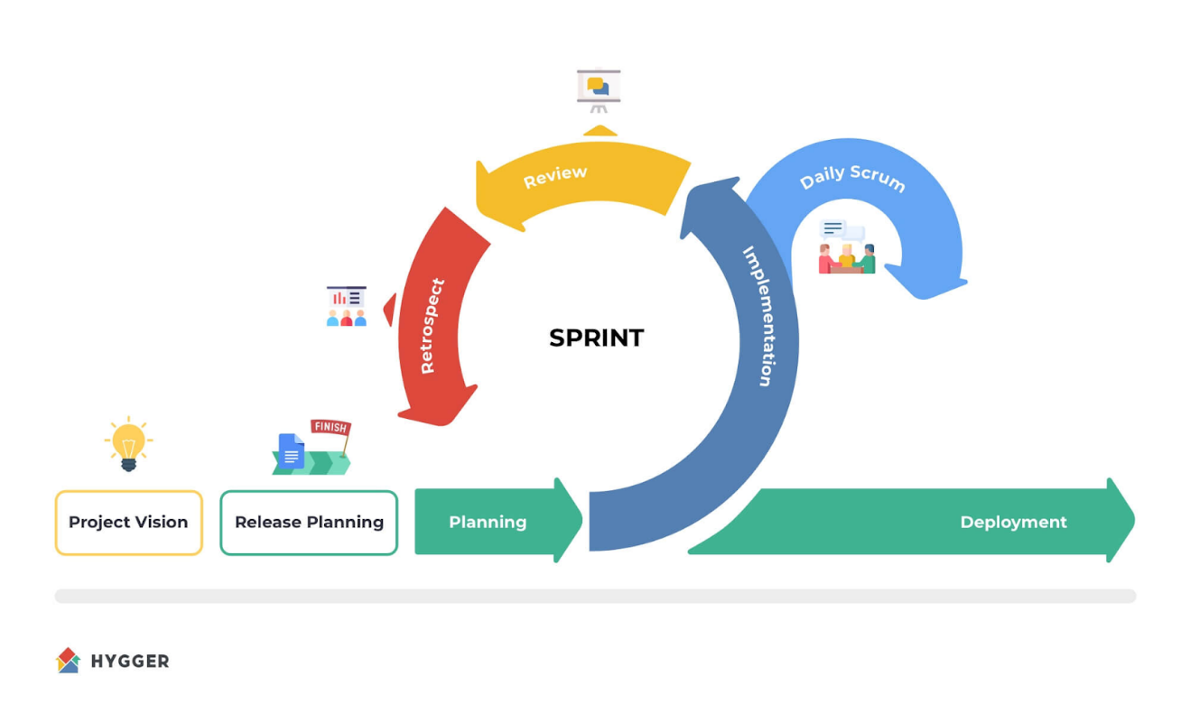

Figure 6. Scrum Framework under Agile Methodology

Hardware and Software Components
The hardware and software components of the NCHire Digital Recruitment Platform refer to the essential hardware and software components required to support its development, implementation, and operation. These resources provide the necessary tools to ensure the system functions efficiently, allowing accurate documentation, reliable monitoring, and effective reporting throughout the recruitment process.
Table 3. Hardware RequirementsHardware Components Specification Requirements
Laptop
At least Intel i5 processor or equivalent
RAM 8 GB
Storage 256 GB SSD

Table 3 Hardware Requirements presents the key components necessary for the platform’s operation. Each item ensures smooth performance, efficient data handling, and reliable connectivity during development and usage.
Table 4. Software RequirementsHardware Components Specification Requirements
Operating System
Windows 10
Code Editor Visual Studio Code
Framework Tailwind CSS
Database Management System MySQL
Local Server XAMPP for local hosting
Table 4 Software Requirements lists the essential software used in developing and operating the NCHire Digital Recruitment Platform. These tools support coding, design, local hosting, and database management, ensuring efficient system functionality and smooth integration of all components.
Project Development Cost Estimation
This section presents the estimated expenses for developing the NCHire platform. Presenting these projected costs ensures proper budgeting and efficient allocation of resources throughout the project.

Table 5. Project Development Cost EstimationExpense Category Estimated Cost
Book Bindings ( 3 Copies )
600.00
Printing (200 pages × ₱3/page (for BW) 850.00 x ₱5-10/page (for Colored))
USB/Storage Device 350.00
Domain & Web Hosting (group’s share) 643.00
System Demo (materials, setup, internet load) 1,500.00
Miscellaneous (papers, transportation, etc..) 1000.00
TOTAL 4,943.00
Table 5 illustrates the projected expenses for developing the NCHire platform, covering costs such as printing, materials, and system demonstration. It provides an overview of resource allocation necessary for successful project execution. The breakdown ensures proper budgeting and planning throughout the development process.
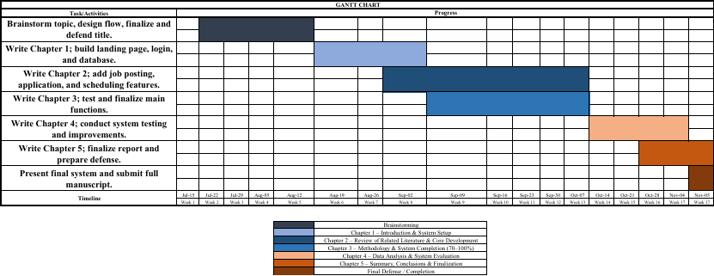
Calendar of Activities (Gantt Chart)

Figure 7. Calendar of Activities (Gantt Chart)
It provides a visual timeline of tasks and milestones, showing how the project’s activities are scheduled over time. It helps track progress, manage deadlines, and ensure that each phase of the project is completed efficiently.
Research Approach
This study utilized a quantitative approach, as it involves the collection and analysis of numerical data to assess the developed system’s effectiveness and performance. The quantitative approach was used to obtain measurable feedback from respondents through structured questionnaires, focusing on indicators such as efficiency, usability, reliability, security, and user satisfaction. This approach allowed the researchers to present objective findings through statistical treatment and interpretations.
Research Design
The study employed a Descriptive–Developmental Research Design. The developmental aspect focused on the design and creation of the NCHire: Digital Recruitment Platform for Norzagaray College, which aimed to digitize the institution’s recruitment process for instructors. The system was developed following standard phases of the Software Development Life Cycle (SDLC), which include Planning, Analysis, Design, Development, Testing, and Evaluation.
The descriptive aspect was used to evaluate the developed system through survey questionnaires administered to selected respondents such as deans, administrators, IT experts and newly hired instructors that will represent the applicants. Their responses helped determine the system’s performance in terms of functionality, usability, reliability, security, and overall impact on the recruitment process.
This combined design ensured that the research not only developed a functional and efficient digital platform but also systematically measured its effectiveness based on user perception and software quality standards, following the ISO/IEC 25010 model.
Research Methodology
To implement the research design, this study will employ a descriptive–developmental methodology. In the descriptive phase, data will be gathered through interviews with deans and applicants to understand the existing recruitment process of Norzagaray College and to identify the challenges encountered in hiring. The information collected will serve as the foundation for defining the system’s functional and non-functional requirements, which will guide the overall design and development of the platform.
In the developmental phase, the NCHire Digital Recruitment Platform will be designed and developed based on the findings from the descriptive phase. The development will follow the principles of the Agile methodology, which emphasizes iterative design, testing, and refinement. This approach will allow the researchers to continuously incorporate user feedback, ensuring that the system remains aligned with stakeholder needs. A pilot implementation will be conducted to assess the platform’s usability, functionality, and accuracy. Feedback from users will then be analyzed, and necessary adjustments will be made to enhance the system’s efficiency and reliability.
Through this methodology, the study aims to ensure that the developed platform effectively addresses the institution’s recruitment needs while promoting a more efficient, organized, and transparent hiring process for Norzagaray College.
Sampling Technique
The study population consisted of instructors from three departments: College of Computing Studies (15), College of Education (24), and College of Hospitality Management (23), with a total of 62 instructors. A proportionate stratified sampling method was used to ensure that each department was fairly represented according to its population size.
The total sample size was set at fifteen (15) instructors, with the sample from each department determined using the formula:
$n_{h}=\frac{N_{h}}{N}×n$
where $n_{h}$is the number of respondents per department, $N_{h}$is the total number of instructors in that department, $N$is the total instructor population, and $n$is the total sample size.
Based on this calculation and rounding to the nearest whole number, four (4) respondents were selected from the College of Computing Studies, six (6) from the College of Education, and five (5) from the College of Hospitality Management. This yielded a total of fifteen (15) instructor respondents. Random selection within each department was performed using a reproducible random number generator (seed = 12345). In addition, three (3) deans were purposively included in the study, bringing the total number of respondents to eighteen (18).
Table 6. Proportional Allocation of Instructors
Department | Population (Nₕ) | Population % | Expected nₕ (for n = 15) | Actual nₕ | Difference
CS | 15 | 24.19% | 3.63 | 4 | +0.37
COED | 24 | 38.71% | 5.81 | 6 | +0.19
HM | 23 | 37.10% | 5.57 | 5 | −0.57
Total | 62 | 100% | ≈15.00 | 15 | —
Table 6 presents the proportional allocation of the instructor respondents per department. The total population of instructors was sixty-two (62), composed of fifteen (15) from the College of Computing Studies, twenty-four (24) from the College of Education, and twenty-three (23) from the College of Hospitality Management. The sample size for instructors was determined to be fifteen (15).
Using the formula:
$n_{h}=\frac{N_{h}}{N}×n$
where $n_{h}$is the number of respondents per department, $N_{h}$is the population of the department, $N$is the total population, and $n$is the total sample size, the expected number of respondents per department was calculated.
The results show that approximately 3.63 respondents should come from the College of Computing Studies, 5.81 from the College of Education, and 5.57 from the College of Hospitality Management. Since it is not possible to have fractional respondents, the computed values were rounded to the nearest whole number, resulting in 4, 6, and 5 respondents, respectively.
This rounding produces minimal differences (ranging from –0.57 to +0.37), which are statistically acceptable and do not significantly affect representativeness. Therefore, the final allocation of 4–6–5 respondents maintain the proportionality of the population while ensuring a manageable total of fifteen (15) instructor participants.
Since the computed values yielded fractional results (3.63, 5.81, and 5.57), these were rounded to the nearest whole numbers—four (4), six (6), and five (5)—to obtain practicable respondent counts per department. According to Cochran (1977) and Lohr (2019), minor rounding deviations in proportionate stratified sampling are acceptable as long as proportional relationships among strata are maintained. To verify that the rounding had minimal effect on proportionality, the expected and actual percentages were compared. The College of Computing Studies increased from 24.19% to 26.67% (+2.48%), the College of Education from 38.71% to 40.00% (+1.29%), and the College of Hospitality Management decreased slightly from 37.10% to 33.33% (−3.77%). These differences are all below ±5%, which is widely regarded in applied social research as a negligible deviation threshold. Therefore, the rounding does not meaningfully distort representativeness, and the final allocation of 4–6–5 respondents remain consistent with the population distribution.
Population of the Study
The population of this study consists of the academic personnel and administrators of Norzagaray College who are directly involved in the institution’s recruitment process. This includes the deans and instructors from three departments of the institution, namely the College of Computing Studies, College of Education, and College of Hospitality Management.
These individuals are identified as key participants in the hiring and evaluation process of applicants. Their knowledge of the existing recruitment procedures and institutional requirements provides essential insights that guide the development and validation of the NCHire Digital Recruitment Platform.
Table 7. Population Distribution of the Study
Department Position/Role Population

College of Computing Studies
Instructors and Dean

15 Instructors / 1 Dean
College of Education
Instructors and Dean
24 Instructors / 1 Dean
College of Hospitality
Management
Instructors and Dean

23 Instructors / 1 Dean

Total 62 Instructors / 3 Deans
Table 7 shows the population distribution of the study, which includes instructors and deans from the College of Computing Studies, College of Education, and College of Hospitality Management. The College of Computing Studies has 15 instructors and 1 dean, the College of Education has 24 instructors and 1 dean, and the College of Hospitality Management has 23 instructors and 1 dean, resulting in a total of 62 instructors and 3 deans.
Respondents of the Study
A total of twenty (20) respondents participated in the evaluation of the NCHire platform. These include three (3) deans representing the College of Computing Studies, College of Education, and College of Hospitality Management; two (2) secretaries involved in the recruitment and documentation process; and fifteen (15) instructors distributed across the three colleges. Specifically, there were four (4) instructors from the College of Computing Studies, six (6) from the College of Education, and five (5) from the College of Hospitality Management.
Table 8. Distribution of Respondents
Respondent Group | College | Number of Respondents | Percentage
Instructors | College of Computing Studies | 4 | 20.00%
 | College of Education | 6 | 30.00%
 | College of Hospitality Management | 5 | 25.00%
Deans | Computing Studies, Hospitality Management, Education | 3 | 15.00%
Secretaries | Office of the College President | 2 | 10.00%
Total | ------ | 20 | 100.00%
The instructors were selected based on their direct involvement or familiarity with recruitment-related activities within their respective colleges, ensuring that the feedback obtained was relevant and informed. The inclusion of deans and secretaries allowed the study to capture both administrative and operational perspectives, providing a comprehensive assessment of the system’s functionality and effectiveness. All responses were treated with strict confidentiality and were used solely for academic and research purposes.
Materials and Instrument Used
To effectively develop the NCHire digital recruitment platform, several materials and instruments will be utilized. These resources will support the collection of relevant data, facilitate user interaction with the system, and ensure that feedback is accurately documented.
The materials to be used will include the NCHire system itself, computers or mobile devices for respondents to access the platform, an internet connection, and the necessary software such as web browsers to run the system. The instrument to be used to collect data is a questionnaire administered to both the deans and applicants, designed to assess the system’s usability, functionality, and overall satisfaction. The questionnaire incorporates a Likert scale, allowing responses to be quantified and analyzed. These materials and instruments enable the researchers to gather comprehensive feedback from actual users to ensure that the NCHire platform meets the needs and expectations of its intended users.

Table 9. Verbal Interpretation Numerical Value Range Interpretation
4.51 - 5.00
Highly Accepted
3.51 - 4.50
Accepted
2.51 - 3.50
Fair
1.51 - 2.50
Less Accepted
1.50 and below
Least Accepted

Table 9 presents the verbal interpretation scale used to evaluate responses based on the Likert scale. It serves as a reference in analyzing the acceptability and effectiveness of the NCHire Digital Recruitment Platform through the participants’ feedback.
Evaluation Procedure
To determine how effective the NCHire digital recruitment platform is in supporting the hiring process of Norzagaray College, an evaluation will be conducted to measure its overall quality and performance. The purpose of this activity is to gather feedback that reflects how well the system performs and how satisfactory it is to its users. The evaluation will be carried out through a structured survey answered by selected respondents such as newly hired instructors that represent the applicants and deans who are directly involved in recruitment activities.

Table 10. ISO Software Evaluation Criteria
Numerical Rating Categorical Response Verbal Interpretation
5
Strongly Agree(SA)
Highly Accepted
4
Agree(A)
Accepted
3
Neutral(N)
Neutral
2
Disagree(D)
Less Accepted
1
Strongly Disagree(SD)
Highly Less Expected

The assessment will follow the ISO/IEC 25010:2011 Software Quality Model, which serves as the framework for evaluating software quality. Using a five-point Likert scale, participants will rate specific areas of the system such as Functionality, Reliability, Usability, Efficiency, Satisfaction, and Maintainability.
Respondents will be asked to use the platform and provide their observations on how easy it is to navigate, how quickly it responds to user actions, how accessible and organized the information is, and how satisfied they are with the overall experience. The collected data will then be analyzed to determine the platform’s level of acceptability and identify which aspects meet or need improvement. The findings will serve as the basis for enhancing the NCHire system to ensure it remains responsive, reliable, and aligned with the needs of its intended users.
Statistical Treatment
This section presents the statistical tools and methods that are used to analyze the data gathered from the respondents. The study uses descriptive statistics, specifically frequency, percentage, and weighted mean, to summarize and interpret the responses obtained from the questionnaire distributed to selected applicants and deans of Norzagaray College. To assess the developed system, a five-point Likert scale was utilized, enabling respondents to evaluate the platform based on the ISO 25010 Software Quality Model. The evaluation criteria covered Functionality, Reliability, Usability, Efficiency, Satisfaction, and Maintainability.
1. Absolute Frequency
The absolute frequency will be used to determine the number of respondents who will select each response option in the questionnaire. It simply will count how many participants will provide a specific answer to an item. This statistical measure will help identify the distribution of responses for each statement related to the NCHire platform’s features and level of acceptability.
Formula:
$f$ = number of respondents per response option
2. Percentage
The percentage will be used to show the proportion of respondents who will select each response relative to the total number of participants. It will provide a clearer view of how widely a certain perception or rating will be shared among the respondents.
Formula:
$Percentage \left(\%\right)=\frac{f}{N} × 100$

Where:
- $f$ = frequency of responses
- $N$ = Total Number of respondents
3. Weighted Mean
The weighted mean will be used to determine the overall average response of the participants for each item in the questionnaire. This measure will assign weights to each response based on their scale value to produce an accurate representation of the respondents’ level of agreement.
Formula:
$Weighted Mean =$ $∑\left(\frac{f × x}{N}\right)$
Where:
- $f$ = frequency of each response
- $x$ = numerical weight assigned to each response
- $N$ = total number of respondents
Requirements Analysis
The requirements analysis for the NCHire Digital Recruitment Platform involved identifying the needs and challenges of Norzagaray College’s existing recruitment process. Data were collected through interviews with instructors who have experience in the hiring process. The analysis aimed to understand the difficulties encountered in the current system, such as delays in application handling and the lack of organized applicant tracking.
The information gathered was used to determine the essential features that the system should provide to improve efficiency and transparency in recruitment. Furthermore, the analysis identified the technical and usability requirements necessary to ensure that the platform is reliable, secure, and user-friendly for both administrators and applicants. These findings served as the foundation for defining the functional and non-functional requirements of the NCHire system.
Requirements Documentation
The requirements documentation formally defines all the necessary features and performance standards of the NCHire Digital Recruitment Platform. It consolidates the results of the requirements analysis and presents them as specific system requirements. These are classified into two main categories: functional requirements, which describe what the system should do, and non-functional requirements, which describe the quality and performance standards the system must meet.
Functional Requirements
The functional requirements define the key operations and objectives that the NCHire Recruitment System must fulfill. The goal of the system is to provide an intuitive online platform where applicants can conveniently apply for job vacancies, while the dean can efficiently manage the entire recruitment process in one centralized system. The platform promotes transparency, faster communication, and organized hiring procedures.
User Account Management Module. This module manages applicant registration, sign-in, and password recovery. It ensures secure account creation through email verification before allowing full access. Applicants can update their personal details and reset forgotten passwords through the email-based recovery process.
Applicant Portal Module. This module allows applicants to browse available job openings, view job details, and apply online. It supports the six-step application process, including personal information input, document submission, interview scheduling, demo teaching, psychological exam, and hiring confirmation. Applicants can track their progress, receive notifications, and save drafts of their applications
Recruitment Management Module. This module enables the dean to create, edit, and remove job postings. It provides a dashboard displaying total jobs, applicants, and ongoing activities. The dean can review submitted applications, schedule interviews, request resubmissions, and make hiring decisions such as “Initially Hired” or “Permanently Hired.”
Screening and Evaluation Module. This module supports the dean in assessing applicants based on uploaded documents and qualifications. It includes tools for scheduling interviews and demo teaching, recording evaluation notes, and updating applicant status throughout each recruitment stage.
Communication and Notification Module. This module delivers updates and messages between applicants and the dean. It automatically sends notifications such as interview schedules, application results, and hiring confirmations through the platform’s interface and email.
Analytics and Data Visualization Feature. This feature presents a graphical representation of the number of applicants per semester, allowing users particularly the deans to easily monitor recruitment trends. Through visual data insights, the system helps in assessing applicant volume over time and supports better understanding of the recruitment flow within each academic period.
Non-Functional Requirements
The non-functional requirements describe the quality attributes and operating standards that the NCHire must meet. These requirements ensure that the system performs efficiently, remains secure, and provides a reliable and user-friendly experience for both applicants and the Dean’s office.
Usability. The system shall have a simple and well-structured interface that allows users to easily navigate through its pages. Applicants should be able to create accounts, upload documents, and check their application status without difficulty. The interface shall use clear labels, readable text, and consistent layouts. It shall also be responsive, ensuring that the platform functions properly on both desktop and mobile devices.
Performance. The system shall provide a fast and stable experience for users. It should respond quickly to commands and remain functional even when multiple users are accessing the platform at the same time. The server and database must be capable of handling a large number of applications and records without affecting performance. Regular system monitoring and optimization shall be performed to maintain smooth operation.
Security. The system shall safeguard all applicant data and prevent unauthorized access. Only registered users and authorized administrators, such as the Dean, shall have access to confidential information. Data transmission shall use secure protocols, and passwords shall be encrypted. The system shall also maintain regular data backups to protect information in the event of a system failure or data loss.
Supportability. The system shall be designed for easy maintenance and updates. The Dean should be able to manage job postings, update content, and make necessary adjustments without affecting the overall operation. Proper documentation and user guides shall be provided to assist with maintenance, troubleshooting, and future system enhancements.
Interfaces. The system shall be compatible with widely used web browsers such as Google Chrome, Mozilla Firefox, Microsoft Edge, and Safari. It shall also function properly on desktop and other mobile devices. The system may include integration with email services to notify applicants about updates and announcements from the Dean’s office, ensuring consistent communication throughout the recruitment process.
Operating Procedure
The development of the NCHire Digital Recruitment Platform for Norzagaray College aimed to modernize the college’s hiring process by creating a system that simplified and organized recruitment tasks. The platform was built to handle applicant data efficiently while keeping information secure and well-managed. During the development process, attention was given to ensuring system functionality, usability, and reliability,
A centralized database was created to store important information such as applicant profiles, job openings, and hiring records. This allowed authorized users, including the dean and applicants, to access and manage recruitment data conveniently. The system included features such as application tracking, document submission, and automated notifications to help both applicants and administrators monitor updates with ease.
The platform features an intuitive interface that is accessible across various devices. Both functional and non-functional requirements were carefully identified and implemented to ensure optimal performance, usability, and reliability. An administrative panel was developed for administrators, deans, and secretaries to manage recruitment activities, including job postings, applicant information, and user accounts. Meanwhile, applicants can view available positions, submit applications online, and monitor their progress through different stages of the hiring process. Overall, the NCHire platform provides a faster, more organized, and transparent recruitment process for Norzagaray College.
Development and Testing and Evaluation Plan
The Development, Testing, and Evaluation Plan outlines the systematic approach used to build, verify, and assess the NCHire Digital Recruitment Platform for Norzagaray College. This ensures that the platform is functional, reliable, and meets the needs of both administrators and applicants.
Development Procedure
The development of the NCHire Digital Recruitment Platform for Norzagaray College followed the Agile software development methodology, which promotes an iterative and collaborative approach. This method allowed the development team to continuously refine the system through user feedback and regular testing, ensuring that each phase contributed to building a reliable, efficient, and user-centered recruitment platform.
Requirements. The process began with gathering and analyzing the requirements of the college’s recruitment process. Interviews and consultations were conducted with the dean and the previous applicants of Norzagaray College to identify existing challenges and determine the desired features of the system. The gathered information served as the foundation for defining the functional and non-functional requirements of the NCHire platform, ensuring that it met both administrative and applicant needs.
Design. After establishing the requirements, the design phase focused on creating the overall structure and interface of the system. This included designing the database, user interface, and workflow diagrams that outline how data would move through the platform. The design emphasized accessibility, simplicity, and responsiveness to ensure ease of use across different devices and user roles.
Development. During the development phase, the actual coding and implementation of the system took place. The team built the platform’s core modules such as applicant registration, job posting and screening. Agile sprints were conducted to allow incremental development, where each completed module was immediately tested and refined based on feedback before moving to the next stage.
Testing. Testing was carried out continuously throughout the development cycle to ensure that the NCHire platform met the required standards of quality and performance. Each module was tested for functionality, reliability, and efficiency to verify that it performed as intended under different conditions. Selected users from Norzagaray College participated in testing sessions to provide insights on usability and overall system experience. Any issues identified during testing were immediately addressed to maintain the stability and readiness of the platform for deployment.
Deployment. After successful testing, the system was deployed in a controlled environment for pilot use. This stage involved setting up the NCHire platform for actual recruitment operations within Norzagaray College. The deployment process ensured that all components worked seamlessly and that users could access the system without technical difficulties.
Review. The final phase involved reviewing the overall performance of the platform based on feedback from administrators, applicants, and technical evaluators. The team assessed whether the NCHire system met its intended objectives and identified areas for improvement. This review guided the final refinements before the system’s full implementation, ensuring that the platform was functional, user-friendly, and aligned with the recruitment goals of Norzagaray College.
Testing Procedure
The testing procedure for NCHire: Developing a Digital Recruitment Platform for Norzagaray College aims to ensure that every part of the system performs well before it is fully implemented. This process helps identify and fix issues early, making sure the platform is functional, reliable, and ready for use. The testing is carried out in several stages: Unit Testing, Integration Testing, System Testing, and Acceptance Testing.
Unit Testing: In this stage, each feature of the system is tested separately to confirm that it works as expected. This includes modules such as applicant registration, job posting, and application tracking. The purpose is to check for any small errors within these components and correct them right away. By testing each unit individually, the development team can make sure that all basic functions are working properly before combining them into a larger system.
Integration Testing: After confirming that individual modules work correctly, they are tested together to ensure they connect and exchange data properly. For instance, when an applicant submits a resume, it should automatically appear in the recruiter’s dashboard. This phase checks that the modules communicate effectively, without losing or duplicating data. Any inconsistencies in the workflow between modules are identified and resolved here.
System Testing: Once all modules are successfully integrated, the platform is tested as a complete system. This stage examines how NCHire performs in real use such as posting jobs, screening applications, and managing hiring records. Testers look at the system’s overall performance, security, and usability to ensure it meets the goals set during the design phase. The outcome of this stage determines if the system is ready for actual use.
Acceptance Testing: The final phase involves testing the platform from the user’s perspective. Selected members of the Norzagaray College hiring team, such as the deans involved in recruitment, will try the system to confirm that it meets their needs. They will test how easily they can post job openings, review applications, and manage evaluations. Feedback from this testing will help finalize the system and ensure that it is ready for full deployment.

Table 11. Test Case Scenario Key Attributes Attributes Description
Test Scenario ID Unique identifier assigned to each test scenario in the NCHire system.

Test Scenario Description Unique identifier assigned to each test scenario in the NCHire system.

Test Case ID Brief explanation of the feature or function being tested.

Test Case Description Summary of what the test aims to verify or validate.

Test Steps Sequence of actions performed to execute the test.

Pre-Conditions Required state or setup before the test begins.

Test Data Input information used during the test process.

Post Conditions System state or output after the test is executed.

Expected Result Outcome that should occur if the system functions correctly.

Actual Result Result observed after executing the test.

Status Indicates whether the test passed or failed.

Executed By Name of the person who performed the test.

Executed Date Date when the test was carried out.

Comments (if any) Additional notes or issues observed during testing.

Table 11 presents the key attributes used to define and document the test case scenarios for the NCHire digital recruitment system. Its purpose is to provide a structured guide for conducting and tracking system tests, ensuring that each test case is properly identified, executed, and evaluated for accuracy and reliability.
Evaluation Plan
The evaluation plan for the NCHire Digital Recruitment Platform aims to ensure that the system meets the required standards of functionality, performance, and user satisfaction before its full deployment. This plan will serve as a guide in determining whether the developed features align with the intended objectives and if the platform operates efficiently across various modules and user levels.
Evaluation will take place after each development cycle following the Agile approach, allowing the team to test and improve system components iteratively. The assessment will focus on major software quality aspects, including functionality, reliability, usability, efficiency, satisfaction, and maintainability. Each component of the system, such as applicant registration, job posting, and hiring management, will be tested to confirm that it performs accurately and consistently under expected workloads.
The evaluation will be conducted through a combination of developer-led testing and user-based assessments. Developers will perform technical testing to verify that the platform’s functions and workflows meet design specifications, while selected users from Norzagaray College will participate in usability testing to provide insights on accessibility, responsiveness, and overall user experience. Results from each evaluation phase will be analyzed to identify areas that require refinement before the next development iteration.
This continuous evaluation process will help ensure that NCHire is not only technically sound but also reliable and user-friendly, meeting the recruitment needs of Norzagaray College effectively.

CHAPTER 4
RESULTS AND DISCUSSIONS
This chapter presents the project’s technical description, testing results from the previous testing cases, and evaluation results from the beneficiary and IT specialists who conducted the assessment.
Presentation, Analysis and Interpretation of Data
This section presents, analyzes, and interprets the results related to the NCHire system. Quantitative data gathered from the respondents were statistically treated to assess the system’s performance based on user feedback and its effectiveness in meeting the study’s objectives.
The data are presented in tables to clearly show key patterns and trends, ensuring that the results are easy to understand and aligned with the goals of the study.
Demographic Profile of the Respondents
This section presents the demographic characteristics of the respondents in terms of age, sex, and designation. A total of 20 respondents participated in the evaluation of the NCHire system, composed of newly hired instructors, academic deans, and secretaries from Norzagaray College. This composition allowed the researchers to gather diverse perspectives from different user groups, ensuring that the evaluation reflected different viewpoints regarding the system’s performance and usability.

Table 12. Frequency Distribution of the Respondents in terms of Age
Age Range | Frequency | Percentage (%)
24–25 years old | 1 | 5.00%
26–27 years old | 5 | 25.00%
28–29 years old | 9 | 45.00%
30 and above | 5 | 25.00%
Total | 20 | 100%

As presented in Table 12, the majority of respondents belong to the 28–29 age group, comprising 9 respondents or 45.00% of the total. This is followed by the 26–27 and 30 and above age groups, each with 5 respondents or 25.00%. The smallest proportion of respondents falls within the 24–25 age range, with only 1 respondent or 5.00%.
Table 11. Frequency Distribution of the Respondents in terms of Gender
Gender | Frequency | Percentage (%)
Male | 8 | 40.00%
Female | 12 | 60.00%
Total | 20 | 100%

As presented in Table 11, the majority of the respondents are female, comprising 12 respondents or 60.00% of the total. Meanwhile, male respondents account for 8 respondents or 40.00%.

Table 13. Frequency Distribution of the Respondents in terms of Category
Category | Frequency | Percentage (%)
Instructors | 15 | 60.00%
Academic Deans | 3 | 12.00%
IT Professionals | 5 | 20.00%
Secretary | 2 | 8.00%
Total | 25 | 100%

As presented in Table 13, the majority of the respondents are instructors, consisting of 15 respondents or 60.00% of the total population. This is followed by IT professionals with 5 respondents or 20.00%, and academic deans with 3 respondents or 12.00%. Meanwhile, the smallest group is composed of secretaries, with 2 respondents or 8.00%.
Testing Result
This section presents the results of the manual test case scenarios conducted on the NCHire system. The testing aimed to verify the functionality, usability, reliability, and overall performance of the system by examining the operations of each module from both the administrative and user perspectives. The objective was to ensure that all system features work as intended and that the platform can effectively support the recruitment process at Norzagaray College.
The test cases were executed step by step, with careful observation of the system’s responses and documentation of whether the expected outcomes were achieved. On the admin, deans, and secretary side, the modules tested included User Management, Job Posting Management, Transfer Applications, Review Submitted Documents, Interview Scheduling, Demonstration Scheduling, and Track Applicant Progress. The testing confirmed that administrators could efficiently manage user accounts, create and update job postings, transfer and monitor applications, schedule interviews and demonstrations, and track applicant progress, all while ensuring the security and integrity of the system’s data. These results indicate that the administrative modules provide comprehensive tools to manage the recruitment process effectively.
On the user side, the modules tested included Account Registration and Login, Job Application Submission, Document Upload, Application Status Tracking, Notifications, Update and Edit Profile, and Account Management. Manual test cases verified that users could securely register and log in, submit job applications successfully, upload required documents without errors, track the status of their applications in real time, receive notifications promptly, and update their profiles and account settings efficiently. These functionalities ensure a user-friendly and accessible platform, supporting applicants throughout the recruitment process.
Overall, the results of the manual testing demonstrated that all modules functioned as intended, with no critical errors or system failures observed. The testing confirmed that the NCHire system is reliable, secure, and capable of supporting both administrative and user operations effectively. By successfully integrating the needs of both administrators and users, the system provides a seamless and efficient digital recruitment process, enhancing the overall experience and operational efficiency at Norzagaray College.

Table 14. Selected Test Case Scenario Attributes from Manual Test Case Results
Test Scenario  Description | Post  Condition | Expected  Result | Status
Verify that admin can create new user accounts for system roles (department head, secretary, admin). | New user information is stored in the system database. | Account successfully created and confirmation message appears. |  | Passed
Verify that admin must fill all required fields (full name, email, phone number, role). | System validates input fields before submission | Error message displays if a required field is empty. |  | Passed
Verify that admin must fill all required fields (full name, email, phone number, role). | System validates input fields before submission. | Created user has correct role and access privileges. |  | Passed
Verify that admin can assign a role to the created account (Admin, Department Head, Secretary).  Verify that admin can select the department when creating a department head account.  Verify that admin cannot create a user account with a duplicate email.  Verify that newly created department head account receives credentials via email.  Verify that applicant can sign up successfully.  Verify that applicant must verify email before sign in.  Verify that applicant enters correct verification code to activate account.  Verify that password and confirm password fields match.  Verify that applicant cannot sign up with an existing email.  Verify that applicant can sign in with valid credentials.  Verify that applicant cannot sign in with invalid credentials.  Verify that applicant can reset password using ‘Forgot Password’.  Verify that applicant can sign out successfully.  Verify that department head can sign in using credentials created by admin.  Verify that department head cannot sign in with incorrect credentials.  Verify that department head can change their password after first sign in.  Verify that department head can recover account using ‘Forgot Password’.  Verify that department head can securely sign out. | System stores the assigned role.  List of departments is displayed.  System checks for existing email.  Department head receives sign-in details containing email and temporary password.  System sends verification code to applicant’s email.  Account remains inactive until verified.  Account status updates to “Email Verified.”  System checks password consistency.  System checks for duplicate accounts.  Applicant is redirected to dashboard.  Sign in fails.  System sends reset link to registered email.  Session ends and user return to sign-in page.  Department head is redirected to dashboard.  Sign-in attempt fails.  Updated password stored in the system.  Reset link sent to registered email.  Session is terminated. | Created user has correct role and access privileges.  Admin selects appropriate department, system saves it.  Error message displays: “Email already exists.”  Email with temporary credentials sent successfully.  Email verification message received.  Applicant cannot sign in until verification is completed.  Applicant can now access the sign-in page.  Error displays if passwords don’t match.  Message: “Email already exists.”  Sign in successful.  Message: “Invalid email or password.”  Applicant resets password successfully.  Sign out successful.  Sign in successful.  Error message: “Invalid email or password.”  Password updated successfully.  Department head resets password successfully.  Redirected to sign-in page. |  | Passed  Passed  Passed  Passed  Passed  Passed  Passed  Passed  Passed  Passed  Passed  Passed  Passed  Passed  Passed  Passed  Passed  Passed
Testers conducted a thorough evaluation of each module within the NCHire system to ensure that all features and functionalities operated as intended. The testing process followed a structured approach, employing the Manual Test Case method, in which each module was individually examined to identify potential issues, bugs, or inconsistencies. This method allowed the testers to validate the accuracy, reliability, and responsiveness of the system, ensuring that it meets the functional requirements and performs efficiently before its official deployment. By systematically assessing each module, the testing process also provided insights into areas for improvement and confirmed that the system can support both administrative and user operations effectively.
System Evaluation Using ISO 25010 Quality Model
To ensure that the NCHire system meets established software quality standards, the developers employed the ISO/IEC 25010 software quality model to assess its acceptability. This internationally recognized framework evaluates software products based on multiple quality characteristics, including functionality, reliability, usability, performance efficiency, security, and overall system impact. The evaluation process involved three groups of users: applicants/instructors, deans, and IT experts, ensuring that feedback was gathered from both administrative, instructional, and technical perspectives. This comprehensive assessment provided valuable insights into the system’s effectiveness, user satisfaction, and readiness for deployment. Each group give feedback through structured survey, and the results were explained based on an established scale of acceptability and effectiveness. The overall results are presented in the following tables with detailed explanation.

A. Level of Acceptability
Instructors
Table 15. Mean of the Factors Considered in Using NCHire in terms of Acceptability
Acceptability | Mean | Interpretation
System Performance | 4.18 | Accepted
System Functionality | 4.43 | Accepted
System Usability | 4.40 | Accepted
System Security | 4.33 | Accepted
System Compatibility | 4.16 | Accepted
Grand Weighted Mean | 4.30 | Accepted

Legends: 4.51 – 5.00: Highly Accepted: 3.51 – 4.50: Accepted; 2.51 – 3.50: Fair; 1.51 – 2.50: Less Accepted; 1.50 and below: Least Accepted.

The assessment of the system's acceptability is shown in Table 15. With the highest rating, System Functionality received a mean of 4.43, showing that instructors find the system features complete and effective. Following closely, System Usability was rated 4.40, indicating that the system is user-friendly and easy to navigate. System Security received a mean of 4.33, reflecting instructors' confidence in the system’s ability to protect sensitive information. System Compatibility, with a mean of 4.16, demonstrates that the system operates well across different platforms and devices. System Performance, with a mean of 4.07, also falls within the accepted range, confirming that the system responds efficiently to user tasks. The Grand Weighted Mean (GWM) of 4.30 indicates that, overall, instructors accept the NCHire system as reliable, functional, secure, and user-friendly. These results suggest that the system meets the expectations of its intended users and is effective in supporting the recruitment process at Norzagaray College.
Academic Deans
Table 16. Mean of the Factors Considered in Using NCHire in terms of Acceptability
Acceptability | Mean | Interpretation
System Performance | 4.44 | Accepted
System Functionality | 4.17 | Accepted
System Usability | 4.25 | Accepted
System Security | 3.83 | Accepted
System Compatibility | 4.22 | Accepted
Grand Weighted Mean | 4.18 | Accepted

Legends: 4.51 – 5.00: Highly Accepted: 3.51 – 4.50: Accepted; 2.51 – 3.50: Fair; 1.51 – 2.50: Less Accepted; 1.50 and below: Least Accepted.

The assessment of the system's acceptability for academic deans is shown in Table 16. With the highest rating, System Performance received a mean of 4.44, indicating that the deans find the system reliable and efficient in responding to tasks. System Usability followed with a mean of 4.25, showing that the interface is user-friendly, while System Compatibility was rated 4.22, confirming it operates well across different platforms. System Functionality received a mean of 4.17, demonstrating that its features are considered complete and effective for administrative tasks. System Security, with a mean of 3.83, also falls within the "Accepted" range, reflecting a satisfactory level of confidence in data protection.
The Grand Weighted Mean (GWM) of 4.46 falls within the “Accepted” range, suggesting that deans accept the NCHire system. The results indicate that the system meets the expectations of administrative users and provides a secure, functional, and efficient platform for managing recruitment processes at Norzagaray College.
Secretary
Table 17. Mean of the Factors Considered in Using NCHire in terms of Acceptability
Acceptability | Mean | Interpretation
System Performance | 4.33 | Accepted
System Functionality | 4.25 | Accepted
System Usability | 4.50 | Accepted
System Security | 4.00 | Accepted
System Compatibility | 4.33 | Accepted
Grand Weighted Mean | 4.28 | Accepted

Legends: 4.51 – 5.00: Highly Accepted: 3.51 – 4.50: Accepted; 2.51 – 3.50: Fair; 1.51 – 2.50: Less Accepted; 1.50 and below: Least Accepted.

The assessment of the system's acceptability for secretaries is shown in Table 17. With the highest rating, System Usability received a mean of 4.50, indicating that secretaries find the system highly user-friendly and easy to navigate. System Performance and System Compatibility both received a mean of 4.33, showing that the system is considered responsive and works well across different platforms and devices. System Functionality was rated 4.25, demonstrating that its features are effective for their tasks, while System Security, with a mean of 4.00, also falls within the "Accepted" range, reflecting a satisfactory level of trust in the system's data protection.
The Grand Weighted Mean (GWM) of 4.28 falls within the “Accepted” range, indicating that overall, the secretaries accept the NCHire system. The results suggest that the system successfully meets the operational needs of its users, providing a reliable, compatible, and user-friendly platform that supports the secretarial duties within the recruitment process at Norzagaray College.
B. Level of Effectiveness
Instructors
Table 18. Mean of the Factors Considered in Using NCHire in terms of Effectiveness
Effectiveness | Mean | Interpretation
Functionality | 4.33 | Accepted
Reliability | 4.20 | Accepted
Usability | 4.38 | Accepted
Performance Efficiency | 4.11 | Accepted
Security | 4.08 | Accepted
Overall System Impact | 4.33 | Accepted
Grand Weighted Mean | 4.22 | Accepted

Legends: 4.51 – 5.00: Highly Accepted: 3.51 – 4.50: Accepted; 2.51 – 3.50: Fair; 1.51 – 2.50: Less Accepted; 1.50 and below: Least Accepted.

The Table 18 presents the mean scores and interpretations of the NCHire system as evaluated by instructors in terms of effectiveness. Among the factors considered, Usability received the highest rating with a mean of 4.38, indicating that instructors find the system intuitive, user-friendly, and easy to navigate, which enhances their overall experience. Functionality and Overall System Impact were also highly rated at 4.33, showing that the system provides all the necessary features to effectively support recruitment tasks and has a positive influence on the process.
Reliability received a mean of 4.20, reflecting that the system is considered dependable for regular use. Performance Efficiency and Security were rated 4.11 and 4.08, respectively, indicating that the system is responsive and provides a secure environment for handling recruitment data.
The Grand Weighted Mean (GWM) of 4.22 indicates that, overall, instructors find the NCHire system effective in supporting recruitment activities. These results suggest that the system meets the functional and operational needs of its users, providing a reliable and efficient platform for academic and administrative tasks.
Academic Deans
Table 19. Mean of the Factors Considered in Using NCHire in terms of Effectiveness
Effectiveness | Mean | Interpretation
Functionality | 4.33 | Accepted
Reliability | 4.00 | Accepted
Usability | 4.50 | Accepted
Performance Efficiency | 4.22 | Accepted
Security | 3.92 | Accepted
Overall System Impact | 4.50 | Accepted
Grand Weighted Mean | 4.19 | Accepted

Legends: 4.51 – 5.00: Highly Accepted: 3.51 – 4.50: Accepted; 2.51 – 3.50: Fair; 1.51 – 2.50: Less Accepted; 1.50 and below: Least Accepted.

The assessment of the NCHire system’s effectiveness for academic deans is presented in Table 19. Among the factors considered, Usability and Overall System Impact received the highest ratings with a mean of 4.50, indicating that the system is user-friendly and significantly contributes to streamlining recruitment processes and improving operational outcomes. Functionality was also rated highly at 4.33, showing that the system provides the necessary features for administrative tasks.
The other factors, including Performance Efficiency (4.22), Reliability (4.00), and Security (3.92), all fall within the "Accepted" range, indicating that the system is considered efficient, dependable, and provides adequate security for administrative use.
The Grand Weighted Mean (GWM) of 4.19 falls within the “Accepted” range, suggesting that overall, academic deans accept the NCHire system as effective. These results demonstrate that the system meets the operational needs of administrative users, providing a reliable and efficient platform that positively impacts recruitment management at Norzagaray College.
Secretary
Table 20. Mean of the Factors Considered in Using NCHire in terms of Effectiveness
Effectiveness | Mean | Interpretation
Functionality | 4.33 | Accepted
Reliability | 4.50 | Accepted
Usability | 4.63 | Highly Accepted
Performance Efficiency | 4.17 | Accepted
Security | 4.00 | Accepted
Overall System Impact | 4.75 | Highly Accepted
Grand Weighted Mean | 4.33 | Accepted

Legends: 4.51 – 5.00: Highly Accepted: 3.51 – 4.50: Accepted; 2.51 – 3.50: Fair; 1.51 – 2.50: Less Accepted; 1.50 and below: Least Accepted.

The assessment of the NCHire system's effectiveness for secretaries is presented in Table 20. Among the factors considered, Overall System Impact received the highest rating with a mean of 4.75, reflecting that the system significantly improves the recruitment process and operational outcomes. Usability was also rated highly with a mean of 4.63, indicating that secretaries find the system very intuitive, user-friendly, and easy to navigate, which enhances their overall experience.
The other factors also received strong ratings. Reliability scored 4.50, Functionality scored 4.33, Performance Efficiency scored 4.17, and Security scored 4.00. All these scores fall within the Accepted range, indicating that the system is considered dependable, well-featured, efficient, and secure for secretarial tasks.
The Grand Weighted Mean of 4.33 indicates that overall, secretaries find the NCHire system effective in supporting recruitment activities. These results suggest that the system meets the functional and operational needs of its users, providing a reliable and efficient platform for administrative tasks at Norzagaray College.
 | Respondent  (Instructors) |  | Respondent  (Deans) |  | Respondent  (Secretary)
CRITERIA | Mean | Interpretation | Mean | Interpretation | Mean | Interpretation
System’s  Performance | 4.18 | Accepted | 4.44 | Accepted | 4.33 | Accepted
System’s Functionality | 4.43 | Accepted | 4.17 | Accepted | 4.25 | Accepted
System’s Reliability | 4.40 | Accepted | 4.25 | Accepted | 4.50 | Accepted
System’s Security | 4.33 | Accepted | 3.83 | Accepted | 4.00 | Accepted
System’s Compatibility | 4.22 | Accepted | 4.22 | Accepted | 4.33 | Accepted
Grand Weighted Mean | 4.30 | Accepted | 4.18 | Accepted | 4.28 | Accepted
Summary of Results from the Respondents
Table 21. Mean of the Factors Considered in Using NCHire in terms of Acceptability

Legends: 4.51 – 5.00: Highly Accepted: 3.51 – 4.50: Accepted; 2.51 – 3.50: Fair; 1.51 – 2.50: Less Accepted; 1.50 and below: Least Accepted.
Table 21 presents the evaluation results of the system based on the responses of instructors, deans, and secretaries across five criteria: system performance, functionality, reliability, security, and compatibility.
Among the instructors, the highest mean score was recorded in System’s Functionality (4.43), followed by System’s Reliability (4.40), both interpreted as Accepted, indicating that the system effectively meets its intended functions and operates reliably. Their overall grand weighted mean of 4.30 signifies that the system is generally accepted by this group.
For the deans, the highest rating was given to System’s Performance (4.44), showing satisfaction with how efficiently the system performs its tasks. The lowest mean was observed in System’s Security (3.83), which, while still Accepted, suggests room for improvement in data protection and confidentiality. The grand weighted mean of 4.18 indicates overall acceptance of the system.
Among the secretaries, System’s Reliability received the highest mean (4.50), implying confidence in the system’s stability and consistency. Their lowest rating was in System’s Security (4.00), though it still falls under the Accepted interpretation. The grand weighted mean of 4.28 also reflects that the system is accepted by this group.
Overall, the results show that all respondent categories positively evaluated the system, demonstrating that it meets the expected standards of functionality, reliability, and performance, with only minor considerations for improvement in security aspects.

Table 22. Mean of the Factors Considered in Using NCHire in terms of Effectiveness
 | Respondent  (Instructors) |  | Respondent  (Deans) |  | Respondent  (Secretary)
CRITERIA | Mean | Interpretation | Mean | Interpretation | Mean | Interpretation
Functionality | 4.33 | Accepted | 4.33 | Accepted | 4.33 | Accepted
Reliability | 4.20 | Accepted | 4.00 | Accepted | 4.50 | Accepted
Usability | 4.38 | Accepted | 4.50 | Accepted | 4.63 | Highly Accepted
Performance  Efficiency | 4.11 | Accepted | 4.22 | Accepted | 4.17 | Accepted
Security  Overall System  Impact | 4.08  4.33 | Accepted  Accepted | 3.92  4.50 | Accepted  Accepted | 4.00  4.75 | Accepted  Highly Accepted
Grand Weighted Mean | 4.22 | Accepted | 4.19 | Accepted | 4.32 | Accepted

Legends: 4.51 – 5.00: Highly Accepted: 3.51 – 4.50: Accepted; 2.51 – 3.50: Fair; 1.51 – 2.50: Less Accepted; 1.50 and below: Least Accepted.

Table 22 presents the mean ratings of the factors considered in using NCHire in terms of effectiveness, as evaluated by instructors, deans, and secretaries. The findings reveal that all respondent groups rated the system as Accepted overall, indicating that the platform effectively meets its intended purpose.
Among the instructors, the highest mean score was observed in Functionality (4.33) and Usability (4.38), both interpreted as Accepted, showing that the system is functional and easy to use. The lowest mean was in Security (4.08), which still falls under the Accepted interpretation. The grand weighted mean of 4.22 signifies that instructors generally find the system effective and dependable.
For the deans, Usability received the highest rating (4.50), interpreted as Accepted, suggesting that the system is user-friendly and efficient to operate. The lowest rating was given to Security (3.92), though still Accepted, implying that improvements in data protection could enhance user confidence. The grand weighted mean of 4.19 indicates that deans find the system satisfactory in terms of effectiveness.
Among the secretaries, Usability (4.63) and Overall System Impact (4.75) received the highest ratings, both interpreted as Highly Accepted, reflecting their strong approval of the system’s ease of use and overall contribution to their work efficiency. The lowest mean was recorded in Security (4.00), which remains Accepted. With a grand weighted mean of 4.32, the secretaries rated the system as Accepted, bordering on Highly Accepted.
In summary, all respondent groups viewed the NCHire platform as effective in terms of functionality, reliability, usability, performance efficiency, and overall system impact. While all factors were rated positively, the data suggest that further enhancements in system security could strengthen user satisfaction even more.

Table 23. IT Specialist Evaluation Table
Performance | Weighted Mean | Interpretation
Readability  Readability of the program source code | 3.60 | Accepted
Ease of Program Maintenance  Testing  Debugging  Modification | 4.40  4.20  4.40 | Accepted  Accepted  Accepted
Adaptation of the source code to other  Version  Programming Language | 3.60  4.00 | Accepted  Accepted
Other Consideration  Low Complexity  Low hardware resources consumption  Source code testing using fault injection | 4.40  4.40  3.60 | Accepted  Accepted  Accepted
Grand Weighted Mean | 4.07 | Accepted

Legends: 4.51 – 5.00: Highly Accepted: 3.51 – 4.50: Accepted; 2.51 – 3.50: Fair; 1.51 – 2.50: Less Accepted; 1.50 and below: Least Accepted.

The NCHire system was evaluated by IT Specialists and received an overall Grand Weighted Mean of 4.07, which falls squarely within the "Accepted" range. This indicates a solid level of technical approval for the system's maintainability and performance. The system's greatest strengths lie in its ease of testing and modification, as well as its low complexity and efficient consumption of hardware resources, all of which received high scores of 4.40. These results suggest the system is well-regarded for its stability and manageability from an IT perspective. The process of debugging also scored a strong 4.20, confirming that resolving issues is generally straightforward. While all factors were deemed acceptable, the areas identified with the most potential for improvement are the readability of the source code, its adaptability to other versions, and advanced testing using fault injection, which all received a rating of 3.60. This indicates that while the system is functionally sound and efficient, enhancing the clarity and documentation of the source code could further improve long-term maintenance and scalability.

CHAPTER V
SUMMARY OF FINDINGS, CONCLUSIONS, AND RECOMMENDATIONS
This chapter presents the summary of the study’s key findings, draws conclusions based on the results, and provides recommendations for future improvements.
Summary of Findings
1. How can the platform minimize delays and redundant tasks in the traditional manual handling of job applications?
The findings revealed that the system’s performance obtained mean scores of 4.18 from instructors, 4.44 from deans, and 4.33 from the secretary, all interpreted as Accepted. These results indicate that the NCHire platform effectively minimizes delays and repetitive processes found in the traditional recruitment system. By providing structured features for sorting applications, tracking applicant progress, and managing interview schedules, the system reduces manual workload and enhances efficiency in handling recruitment records. Moreover, the overall system impact received mean scores of 4.33 from instructors, 4.50 from deans, and 4.75 from the secretary, with interpretations ranging from Accepted to Highly Accepted. This suggests that the platform had a significant positive influence on the overall recruitment process by improving organization, timeliness, and accessibility of data, ultimately leading to a more systematic and responsive hiring environment for Norzagaray College.

2. How can the system be developed to ensure high usability that leads to a more efficient application experience for its users?
Results show that the system’s usability gained a mean score of 4.38 from instructors, 4.50 from deans, and 4.63 from the secretary, interpreted as Accepted to Highly Accepted. This demonstrates that the platform was developed with a strong emphasis on user experience and accessibility. The interface was perceived as intuitive, easy to navigate, and visually organized, allowing users to perform tasks efficiently without confusion. These findings confirm that the NCHire system successfully delivers an efficient and satisfying user experience, aligning with the users’ needs and promoting faster completion of recruitment-related activities.
3. How can the system handle sensitive data in terms of data security, confidentiality, and integrity?
In terms of security, the system received mean scores of 4.33 from instructors, 3.83 from deans, and 4.00 from the secretary, all interpreted as Accepted. These results indicate that the NCHire platform is capable of handling sensitive information in a manner that upholds confidentiality, integrity, and data protection throughout the recruitment process. The findings reflect that users generally perceive the system as dependable in preventing unauthorized access and ensuring that applicant information remains secure and intact. Although the ratings from the deans were slightly lower compared to the other respondents, the overall assessment still supports that the platform’s existing security features such as controlled user access, data verification, and account management function sufficiently to protect information and maintain the privacy of records. This suggests that while the system’s security is acceptable and effective, continued monitoring and refinement of its protective mechanisms would further strengthen its reliability in safeguarding data.
4. How can the system be tested to verify its functionality, reliability, and security?
The system was evaluated across multiple quality criteria such as functionality, reliability, and security, with consistently high mean ratings from all respondent groups. Specifically, functionality obtained 4.43 from instructors, 4.17 from deans, and 4.25 from the secretary; reliability received 4.40, 4.25, and 4.50, respectively; and security recorded 4.33, 3.83, and 4.00. All were interpreted as Accepted. These findings confirm that the system was successfully tested and validated according to the ISO/IEC 25010 software quality standards. The results indicate that the NCHire platform performs as intended, operates consistently under normal conditions, and provides adequate security for both users and data.
In addition, the developers conducted software testing using manual test case scenarios to assess the system’s functionality and its operations in relation to the controls and processes during use. The testing confirmed that the system performs reliably and consistently, meets its functional requirements, and supports efficient and accurate recruitment processes.
5. How can the system be evaluated in terms of its overall impact on the recruitment process and its alignment with institutional goals, following the International Standard ISO/IEC 25010 for software quality evaluation?
The overall evaluation of the NCHire platform revealed grand weighted means of 4.30 for instructors, 4.18 for deans, and 4.28 for the secretary in terms of acceptability, and 4.22, 4.19, and 4.32, respectively, in terms of effectiveness. All of these were interpreted as Accepted. These results signify that the system meets the essential software quality characteristics defined under ISO/IEC 25010, particularly in functionality, reliability, usability, performance efficiency, and security.
In addition to the responses from institutional users, the evaluation conducted by IT specialists yielded a grand weighted mean of 4.07, also interpreted as Accepted. The specialists rated the system’s readability of the source code (3.60), ease of program maintenance (4.40), testing (4.20), and modification (4.40) positively, indicating that the program structure is organized, understandable, and maintainable. Similarly, criteria such as adaptation to other programming languages, low complexity, and low hardware resource consumption were all accepted, demonstrating the platform’s efficiency and scalability from a technical perspective.
Taken together, these findings confirm that the NCHire platform has been evaluated comprehensively in terms of both user experience and technical performance. The consistent Accepted interpretations across all respondent groups show that the system aligns well with institutional goals by providing a dependable, efficient, and data-oriented recruitment process. Furthermore, the IT specialists’ evaluation reinforces that the platform adheres to good software engineering practices, ensuring sustainability and maintainability for future improvements. Hence, NCHire can be regarded as a valuable institutional tool that contributes to the modernization and continuous improvement of Norzagaray College’s recruitment operations.

Conclusions
Based on the findings discussed in the previous chapters, the developers concluded that NCHire: Developing a Digital Recruitment Platform for Norzagaray College is well-received, feasible for deployment, and holds significant potential to improve the recruitment process. These results indicate that NCHire can effectively support the college in modernizing and digitizing its recruitment practices.
Recommendations
NCHire: Developing a Digital Recruitment Platform for Norzagaray College is recommended for its target users, as the developer’s study, data collection, and evaluation indicate that it successfully meets its overall objectives.
Based on the findings, the following recommendations are proposed:
- The developers recommend that future developers design the system to accommodate larger volumes of applicants and more complex recruitment workflows while maintaining speed, usability, and data integrity.
- For future developers, enhance the NCHire system by adding new features such as advanced reporting, analytics for recruitment trends, integration with other institutional systems to improve overall functionality and efficiency, and automatic resume and document checking to further improve the efficiency of the recruitment process. This enhancement could reduce manual review time, minimize errors, and support faster decision-making, while still maintaining data accuracy and reliability.
- For future researchers, further studies are encouraged to examine the long-term impact of digital recruitment systems on hiring efficiency, user satisfaction, and institutional outcomes. Comparative analyses with other recruitment platforms, as well as investigations into emerging technologies and potential system enhancements, could provide valuable insights for the continuous improvement of recruitment practices.
By following these recommendations, future developers and researchers can contribute to ensuring that NCHire remains an effective, reliable, and user-friendly platform, while also supporting further studies, improvements, and innovations that enhance the efficiency and management of the recruitment process at Norzagaray College.

